After successful Thunderdome installation, Thunderdome appears in the Vault Explorer Tools menu, (see Fig.1). To launch it, click, depending on your needs, *Backup Vault Settings*, *Create Deployment*, Deploy.

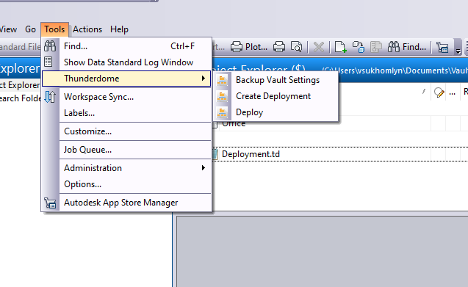

*Figure 1. Thunderdome in the Tools menu*

Functionality

## **Backup Vault Settings**

This function saves all settings in an archive file (see Fig. 2). This feature has remained unchanged. The Restore Vault Settings feature has been removed in the Autodesk version.

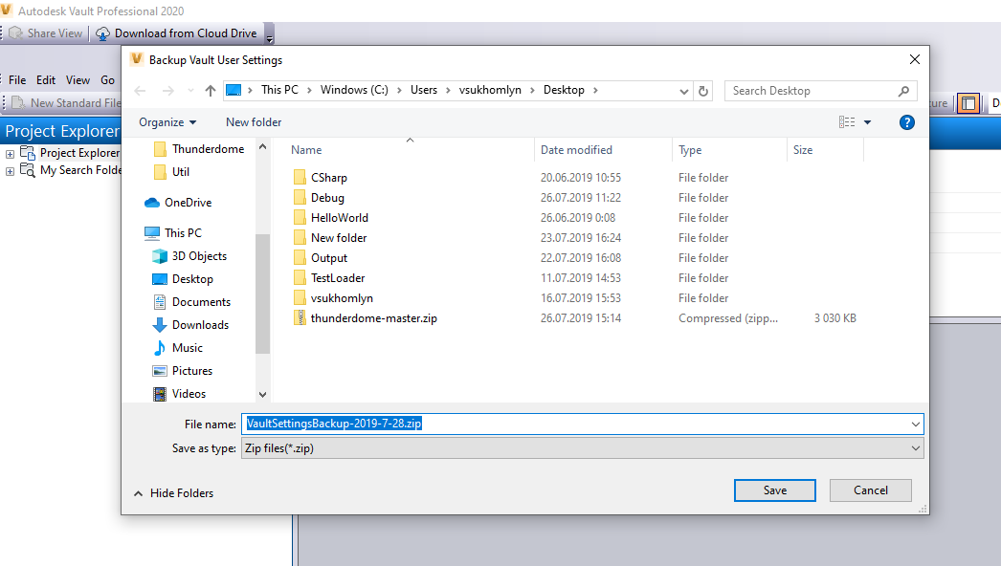

*Figure 2. Backup Vault Settings in the Thunderdome menu*

## **Create Deployment**

To use this feature, take these steps:

* 1. In the Tools menu, point to Thunderdome, and then click Create Deployment (see Fig. 3).

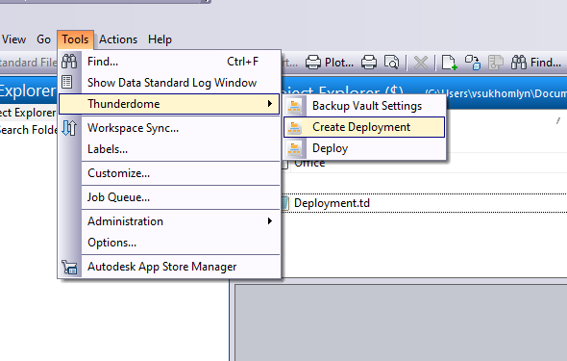

*Figure 3. Create Deployment in the Thunderdome menu*

**Now only admin can do the deployment!**

1. In the “Create Deployment” dialog box (see Fig. 4) select the type of deployment, there are two types, default or new, if you choose the default, then proceed to the next steps.
2. By default, forced deployment is disabled, if you enable it, the user will constantly be offered to update the data and he will not be able to select the item: “No, and never ask me”.
3. In the default mode, we cannot change the package name.
4. In the Deployment folder box, type the deployment folder name, or click the Folder button to select it. The default folder is $/DCA.
5. Under Deployment Contents, select the checkboxes of the settings you want to be in the deployment file.
6. If we select the item - Add folder, then we have to highlight another over the dialog box (see Fig. 5):

* The default folder is $ / DCA. If you want to choose among the folders that are in the repository, then select one of the child folders in the directory.
* If you want to select a folder from a local disk, enabled option - Set a custom destination option, and select the folder you need (see Fig. 6).

**If we do not have a single default deployment file, we first need to choose the path for the default file and after choosing a new type of deployment, we will create two files.**

1. If you selected a deployment type – new (see Fig. 7):
2. In the package name, enter the name you invented and click create.
3. In the Deployment folder box, type the deployment folder name, or click the Folder button to select it. The default folder is $/DCA.
4. Under Deployment Contents, select the checkboxes of the settings you want to be in the deployment file.
5. Click OK to complete.

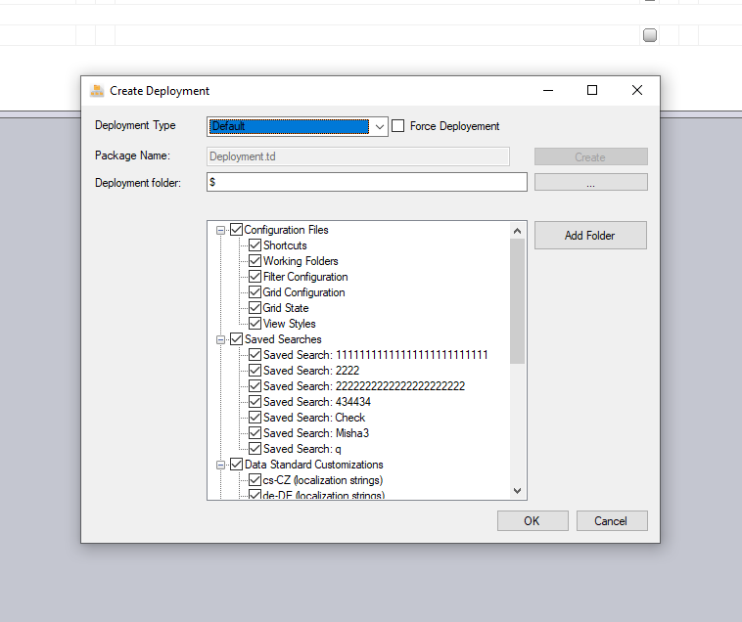

*Figure 4. The Create Deployment window dialog*

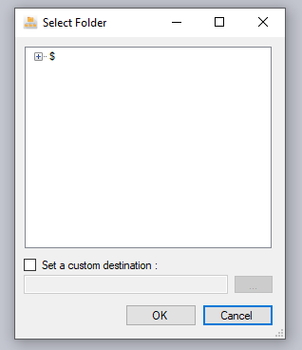

*Figure 5. Add Select Folder*

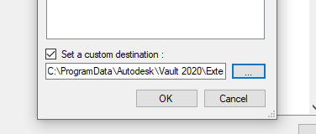

*Figure 6. enabled option - Set a custom destination option*

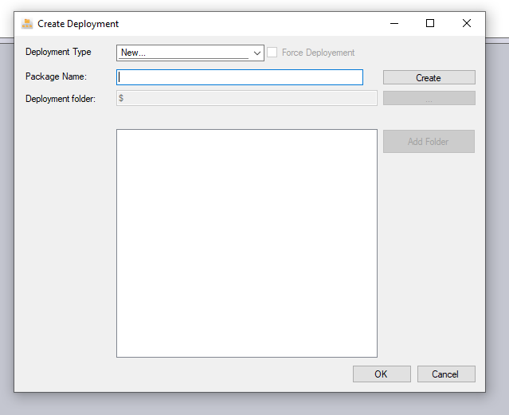

*Figure 7. Select Deployment Type – New*

When the add-in created the deployment, a notification appears (see Fig. 8).

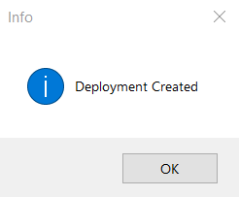

**One repository can have only one default deployment file and many created by type - New, with different names.**

## **Updates**

After completing the deployment and when opening the current Vault project, you will be notified of the available updates, with disabled option Force Deployment (see Figure 9)

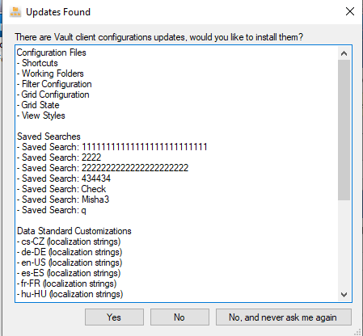

*Figure 9. The Thunderdome Update dialog*

If we have enabled the option - Force Deployment type (see Figure 10).

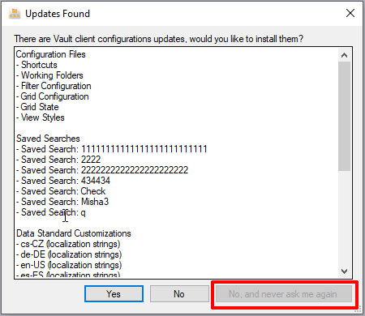

*Figure 10. The Thunderdome Update dialog (Selected Force Deployment)*

**If we have created a new type of deployment, after launching the current project we will not be able to automatically load new updates.**

## **Deploy**

To use this feature, take these steps:

1. In the Tools menu, point to Thunderdome, and then click Deploy (see Fig. 11).
2. In the deployment window, from the drop-down list, select the deployment package you previously created (see Fig. 12).
3. After you have selected the desired deployment, a window will appear telling you that it has loaded successfully (see Fig. 13). and you need to restart the program.

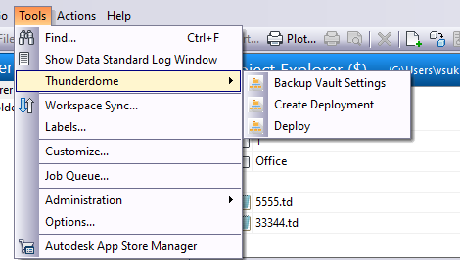

*Figure 11. Deploy in the Thunderdome menu*

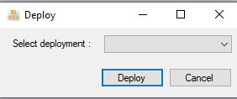

*Figure 12. Thunderdome Deploy function*

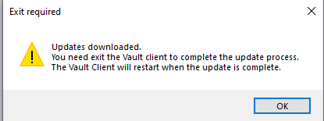

*Figure 13. A notification dialog with updates instructions*